**TRAFFIC SIGNAL DESIGN USING ATMEGA32**

**ABSTRACT:**

**INTRODUCTION:**

Traffic light control systems are widely used to monitor and control the flow of automobiles through the junction of many roads. Nowadays, many countries suffer from the traffic congestion problems that affect the transportation system in cities and cause serious dilemma. In spite of replacing traffic officers and flagmen by traffic systems, the optimization of the heavy traffic jam is still a major issue to be faced, especially with multiple junction nodes. The rapid increase of the number of automobiles and the constantly rising number of road users are not accompanied with promoted infrastructures with sufficient resources. Partial solutions were offered by constructing new roads, implementing flyovers and bypass roads, creating rings, and performing roads rehabilitation.

However, the traffic problem is very complicated due to the involvement of diverse parameters. First, the traffic flow depends on the time of the day where the traffic peak hours are generally in the morning and in the afternoon; on the days of the week where weekends reveal minimum load while Mondays and Fridays generally show dense traffic oriented from cities to their outskirts and in reverse direction respectively; and time of the year as holidays and summer

Traffic lights, developed since 1912, are signaling devices that are conceived to control the traffic flows at road intersections, pedestrian crossings, rail trains, and other locations. Traffic lights consist of three universal colored lights: the green light allows traffic to proceed in the indicated direction, the yellow light warns vehicles to prepare for shortstop, and the red signal prohibits any traffic from proceeding.

In our project Traffic signal design using ATMEGA32 “ATMEGA 32 “is the heart of TRAFFIC SIGNAL.

TRAFFIC lights are connected to B , D ports. This project contain 12 LEDS(4 Red,4 orange,4 green).

This is an Time based traffic control system.

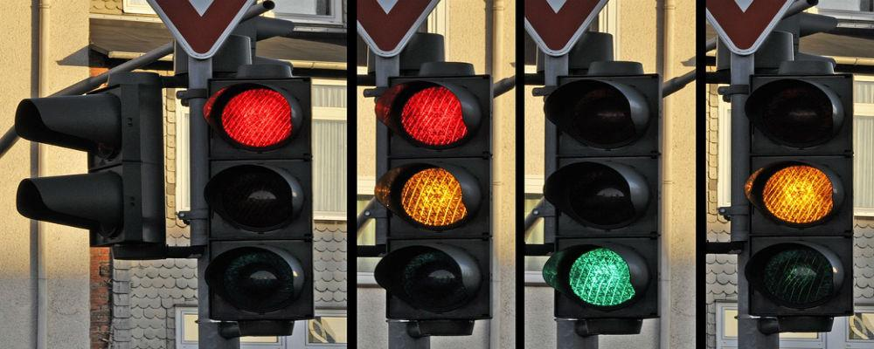

**COMPONENTS USED:**

* ATMEGA 32
* 4 Traffic signals
* Connecting wires

**SOFTWARE USED:**

* SimulIDE